Experiment No. 1

Title: Website building and hosting it.

Batch: B–1 Roll No.: 16010422234 Experiment No.: 1
_________________________________________________

Aim: Build a website and host it.
_________________________________________________

Resources needed: Web development framework, hosting domain
_________________________________________________

Theory:

Develop a website having minimum 4 to 5 linked web pages.

Host it on any domain.
_________________________________________________

Results: (Screenshots of hosting steps and web pages)

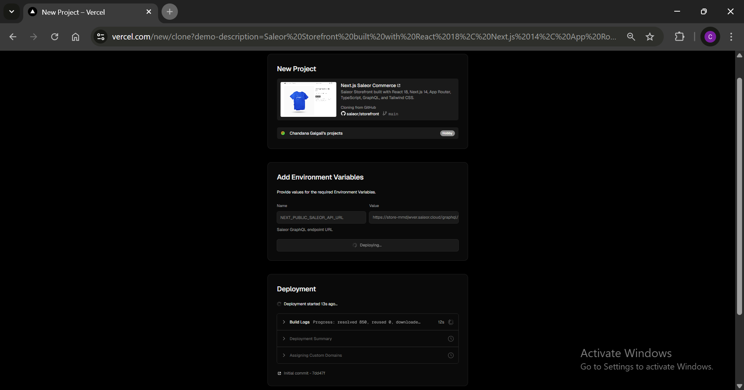

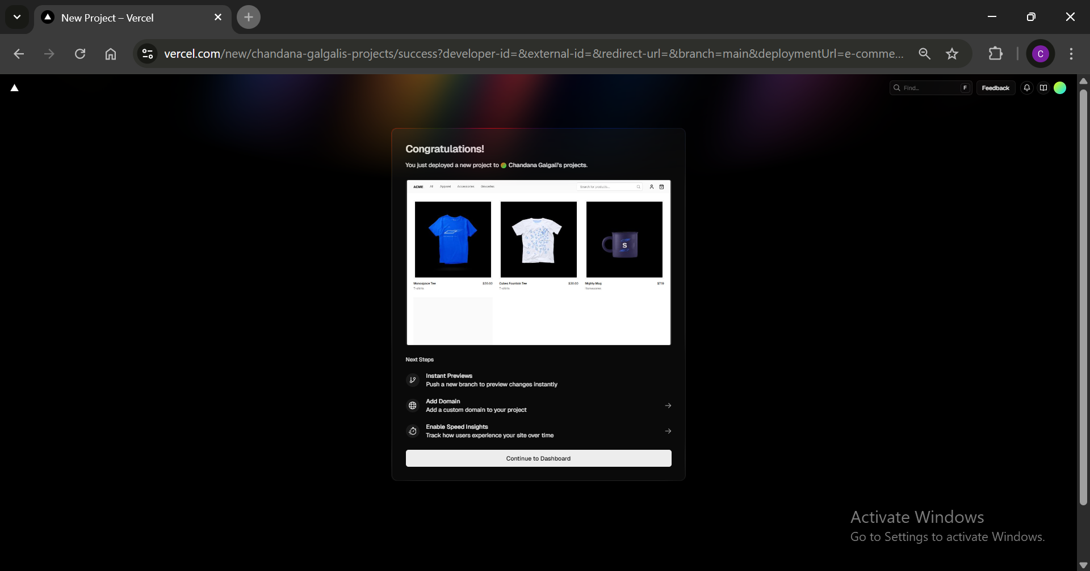

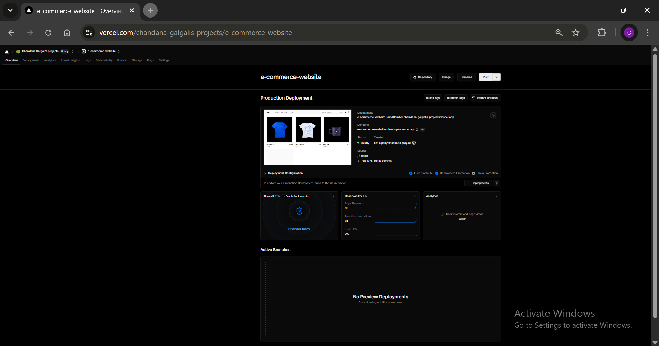
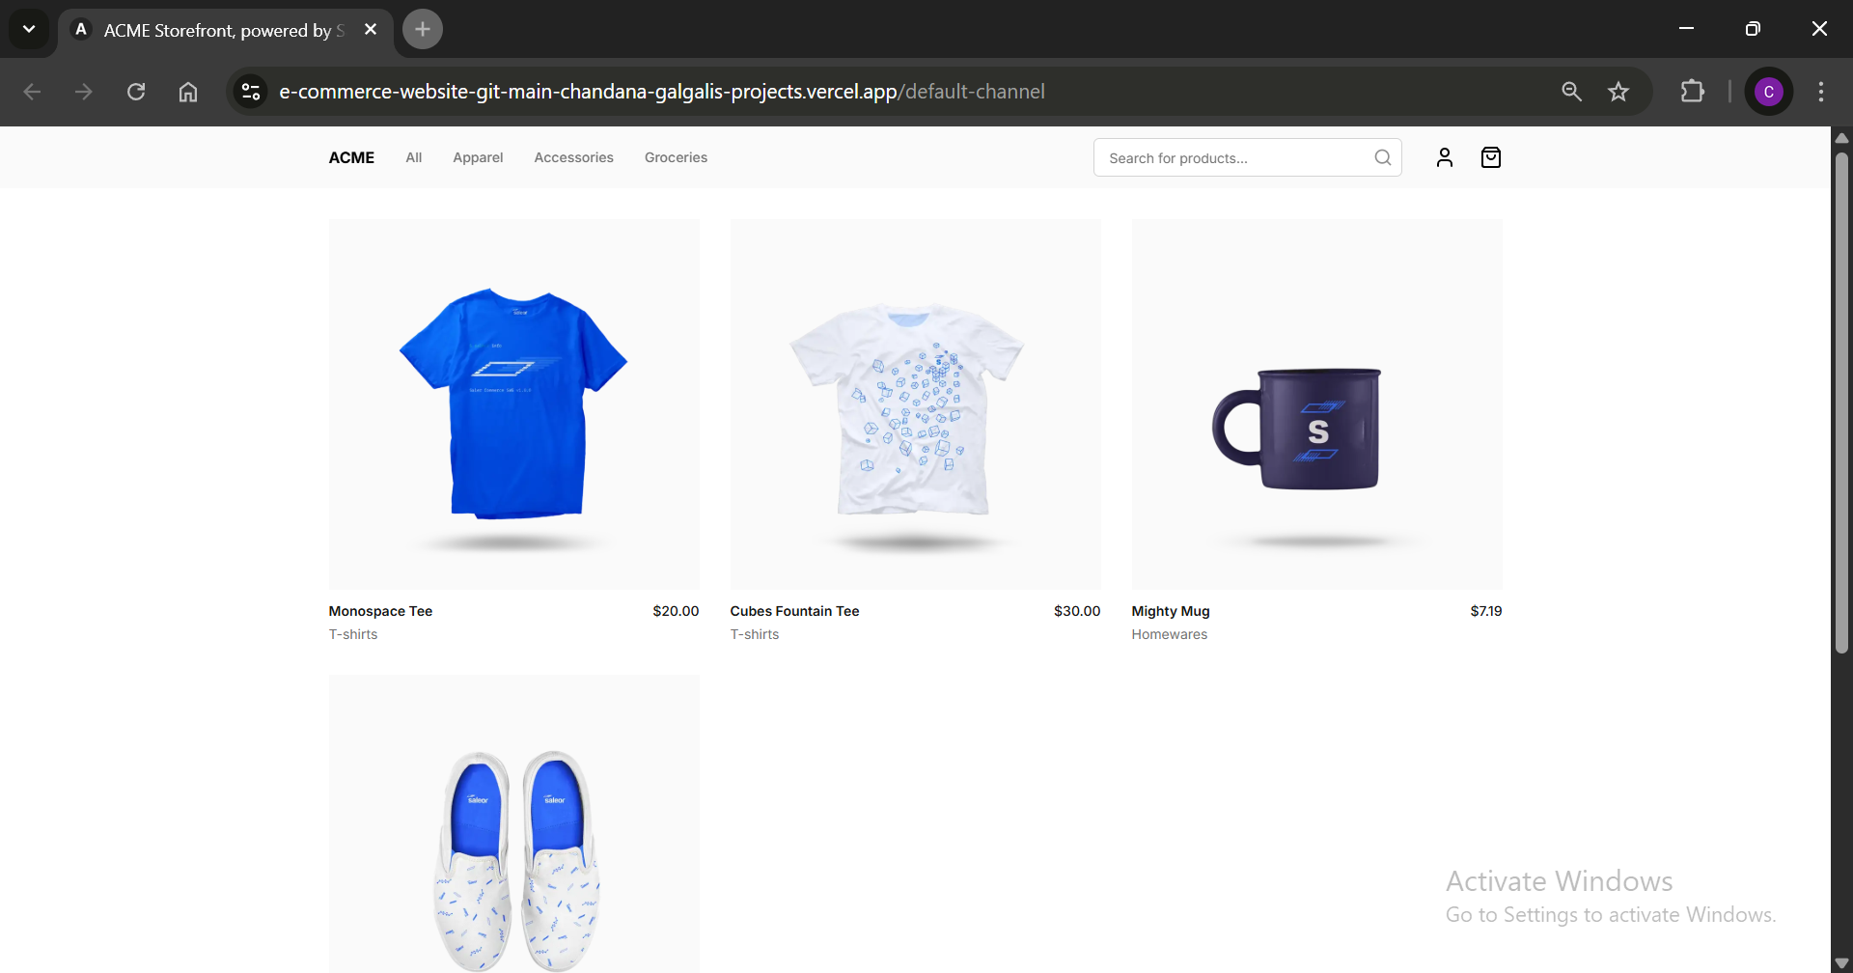
_________________________________________________
Questions:
- Explain any two digital marketing channels.
a) Social Media Marketing (SMM):
Social media marketing involves promoting products or services through social media platforms such as Facebook, Instagram, Twitter, LinkedIn, etc. By creating engaging content and running targeted advertisements, businesses can interact directly with their audience and drive traffic to their website. Social media also allows for real-time feedback and customer interaction, making it an essential channel for building brand awareness and customer loyalty.
b) Search Engine Optimization (SEO):
SEO is the practice of optimizing a website's content, structure, and technical aspects to rank higher in search engine results pages (SERPs). By focusing on keyword research, on-page optimization (e.g., meta tags, headings, content quality), and off-page strategies (e.g., backlinks), businesses can increase their visibility and organic traffic. A strong SEO strategy leads to improved website rankings, better user experience, and higher conversion rates.
_________________________________________________

Outcomes: CO2 – Understanding search engine optimization essentials
_________________________________________________
Conclusion: (Conclusion to be based on the objectives and outcomes achieved)
The experiment focused on developing a website with multiple linked pages and hosting it on a domain, which provided hands-on experience in both web development and hosting. This exercise demonstrated the importance of understanding the technical aspects of website creation and the deployment process. Additionally, learning about digital marketing channels highlighted the strategic approaches required to promote websites and attract traffic. The outcomes achieved from this exercise meet the course objectives, specifically in understanding the digital marketing paradigm and its real-world applications for web-based platforms.
_________________________________________________
Grade: AA / AB / BB / BC / CC / CD /DD

Signature of faculty in-charge with date
_________________________________________________
References:
- Eric Greenberg, Alexander Kates, “Strategic Digital Marketing: Top Digital Experts Share the Formula for Tangible Returns on Your Marketing Investments” McGraw Hill Education 1st edition, 16 August 2013.
- Jan Zimmerman “Web Marketing For Dummies” Willy Publishing 3rd Edition, 2011.
- Jan Zimmerman, Deborah Ng, “ Social Media Marketing All-in-One For Dummies” Willy Publishing 4th Edition, 2017.
- Eric Enge, Stephan Spencer, Jessie Stricchiola, Rand Fishkin, “The Art of SEO”, 2nd Edition Mastering Search Engine Optimization O'Reilly Media 2nd Edition, 2012
- John I Jerkovic, “SEO Warriors” O'Reilly Media 1st edition, 2009
_________________________________________________

